* **Activity 6:**

Copying Rows from Another Table

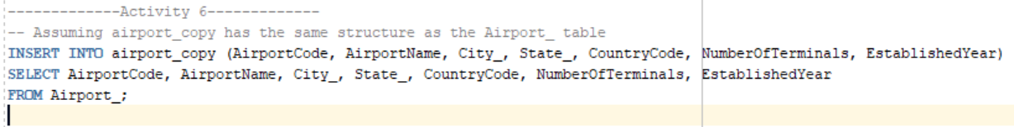

OUTPUT: